

KENYA HIGH 2025 PREDICTION
KCSE TEST EXAM
231/3
BIOLOGY
PAPER 3 (PRACTICAL)
TIME: 1¾ HOURS

NAME……………………………………………………………………………………….
SCHOOL……………………………………………… SIGN………………………..
INDEX NO……………………………………………. ADM NO……………………

(Kenya Certificate of Secondary Education)

INSTRUCTIONS TO CANDIDATES
- Answer all the questions in the spaces provided.
- You are required to spend the first 15 minutes of 1¾ hours allowed for this paper reading the whole paper carefully before commencing your work.
- Candidates may be penalized for recording irrelevant information and for incorrect spelling especially of technical terms.
FOR EXAMINER’S USE ONLY
QUESTION | MAX. SCORE | CANDIDATE’S SCORE
1 | 13
2 | 12
3 | 15
TOTAL | 40

- You are provided with a fruit labeled K. You are required to cut transversely through the middle section of the fruit using the knife provided.
- Cut a 1cm slice from one half of the fruit and remove the peel. Place the soft part of the fruit in a mortar and mash it into a fine paste using a pestle. Add 10ml of distilled water into the paste and stir the mixture, then transfer it into a beaker.
- Using the reagents provided, carry out appropriate food tests on the mixture as you fill in the table below. (11 marks)
Food substance | Procedure | Observation | Conclusion

- Name the deficiency disease in children that may result from feeding them on specimen K alone especially after weaning. (1 mark)
…………………………………………………………………………………………………………
- Identify the hormone responsible for ripening of the specimen K above. (1 mark)
…………………………………………………………………………………………………………

- The photographs below show various types of fruits.
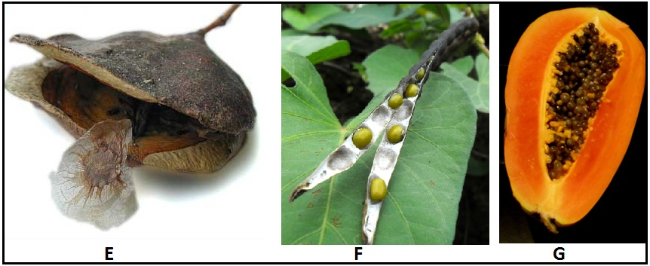
- (i) State the mode of dispersal of the fruit in photograph E. (1mark)
…………………………………………………………………………………………………………
- Give a reason for your answer. (1mark)
…………………………………………………………………………………………………………
…………………………………………………………………………………………………………
- (i) What type of fruit is shown in photograph F? (1mark)
…………………………………………………………………………………………………………
- Give a reason for your answer. (1mark)
…………………………………………………………………………………………………………
…………………………………………………………………………………………………………
- Explain how this fruit is suited to its mode of dispersal (2 mrks)
…………………………………………………………………………………………………………
…………………………………………………………………………………………………………
…………………………………………………………………………………………………………
- (i) Name the type of fruit in photograph G. (1mark)
…………………………………………………………………………………………………………
- Give two reasons for your answer. (2 marks)
…………………………………………………………………………………………………………
…………………………………………………………………………………………………………

- Name the type of placentation in this fruit. (1mark)
…………………………………………………………………………………………………………
- State two ways in which the fruit is adapted to its mode of dispersal. (2 marks)
…………………………………………………………………………………………………………
…………………………………………………………………………………………………………
…………………………………………………………………………………………………………

- Study the photographs below and answer the questions that follow.
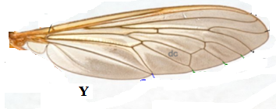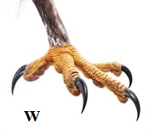
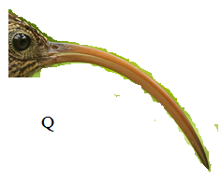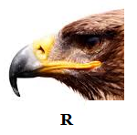
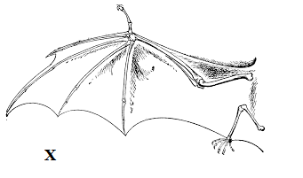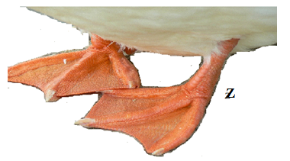

- Name the type of structures shown by: [2marks]
- X & Y ……………………………………………………………………………….
- W & Z ………………………………………………………………………………..
- State the structural difference between structures X and Y [2 marks]
…………………………………………………………………………………………………………
…………………………………………………………………………………………………………
…………………………………………………………………………………………………………
- Name the type of evolution shown by structures Q and R [1 mark]
Q……………………………………………………………………………………………………
R……………………………………………………………………………………………………
- State the adaptations of structures W and Z (2 marks)
W …………………………………………………………………………………………………
Z …………………………………………………………………………………………………

- Name the types of skeletons shown by structures X and Y [2mks]
X …………………………………………………………………………………………………
Y ……………………………………………………………………………………………………

- By comparing structures Q and R, predict the type of food being fed on by the animals and give a reason in each case. [4 marks]
Q………………………………………………………………………………………………………………………………………………………………………………………………………………
R………………………………………………………………………………………………………………………………………………………………………………………………

- A part from structures X and Y, name two other examples of similar structures in animals. [2 marks]
…………………………………………………………………………………………………………
…………………………………………………………………………………………………………

